**CESI in R: Water Quantity Indicator calculator**

**CREATION DATE: May 19, 2017**

**UPDATE DATE: January 10, 2019**

**UPDATED BY: Michelle Fairbrother**

**(1) Program installation**

This tool requires R and RStudio (coding), and QGIS (mapping) to function. These programs are available through the government Software Center, but as open source software they can also be loaded directly from the respective websites (Appendix III). See Appendix II for the versions used with the code provided in this package.

Internet access is also required to run the code as it will check for the Hydat database and download automatically if it is not in the Dependencies folder. Note: If Hydat has been previously downloaded this check will skip, so if a newer version is preferred, delete or move the Hydat.sqlite file and it will be replaced automatically.

**(2) Introduction to R and RStudio**

For the purposes of this calculator, RStudio organizes each chapter of code and they are run in succession until all output tables are automatically generated. The main page of the code is similar to a table of contents (see below) to run each section in order. See Appendix I for a general overview of the RStudio and where plots, data items, and code chapters are stored.

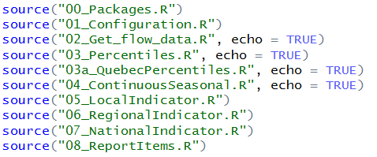

When the code is initiated, information will appear in the console that will inform as to the status of processing. Some sections take longer than others to run, especially those that are grabbing large amounts of data from Hydat and dividing into smaller tables. In a few places, warnings may appear, but this does not mean an error has occurred.

The main use of this calculator is to create the database entry tables for the local and regional CESI indicators for bi-annual reporting. A PDF document can also be produced to summarize station information for the focal year and provide additional information on data quality. The R project is structured such that once the configuration details are set, the code chapters are run in succession to produce the output files.

**Using the CESI WQI Calculator**

To open the R Project, double-click on the .rproj file in the root folder or select the project in RStudio by navigating to File > Open Project. Note that most of the instructions and documentation can be found in the code itself as outlined in the 000_Run_All code. However, the following steps provide a general overview for use of the calculator.

*Running the scripts*

1. If the tabs with the individual R scripts are not already displayed, navigate to the Files window (typically bottom right) and open the Run_all and Configuration scripts. Make changes as needed to the Configuration file and save once updated. Return to the Run_all script.
2. Run the “00_Packages.R” script and all packages should install and load. The versions of each package have been recorded in the comments in case the script is used in future years and there have been updates to package functions. If the HYDAT package does not load, go to Tools > Install packages and install it from the zip file in the Dependencies folder.
3. Now each script up until the Local Indicator can be run. These scripts work well if they are run one at a time, and ensure that the Firefox browser is closed before running (for speed). The output spreadsheet will be captured in Output > Year.
4. If the regional indicator script throws an error, this means that the station indicated in the error is not in the downstream stations coverage tree. Add this station to the list at the top of the script, and re-run to produce the spreadsheets.
5. The National Indicator and Report Items scripts can be run, and the outputs will be returned in the year’s folder.

**Maps and R Markdown**

In addition to the output tables produced in previous steps, a summary report for the year (including maps) can be created in a few additional steps. Maps are created using QGIS and the instruction document in the Map Creation folder. Once the jpg maps are made, the image links in the R Markdown script (can be opened alongside the code chapters in RStudio) will have to be updated for the current year. With the script saved to the correct map image paths, the R Markdown script can be rendered within the Run_all script to produce an internal report.

**APPENDIX**

**Appendix I: RStudio Layout**

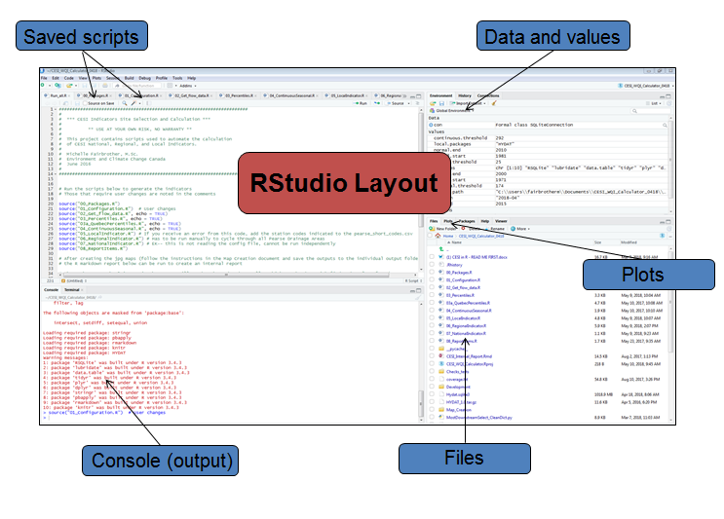

**Saved scripts:** Code “chapters” (.R files) can be opened and displayed in order

**Data and values:** Each item that is created by the code is retained here. Often items are removed to save memory space.

**Console:** This is where progress, warning, and error messages will appear.

**Plots:** This is where graphs and charts will be displayed.

**Files:** All files in the root folder are listed here, and can be clicked on to view within RStudio.

**Appendix II: Program version tracker**

|  |  |  |  |  |
| --- | --- | --- | --- | --- |
| Date | Code version | R version | RStudio version | QGIS version |
| January 2019 | 2.0 | 3.4.0 | 1.1.383 | 3.4.1 |

**Appendix III: Websites**

R Studio: <https://www.rstudio.com/products/RStudio/>

R: <http://cran.utstat.utoronto.ca/>

QGIS: <https://qgis.org/en/site/forusers/download.html>

HYDAT database: <http://collaboration.cmc.ec.gc.ca/cmc/hydrometrics/www/>